Ex.no:6b | DATA VISUALIZATION USING POWER BI

AIM

To visualize and analyze the Fashion Products Analysis dataset using Line Chart, Bar Chart, Pie Chart, Histogram, Scatter Plot, and Box Plot with Matplotlib to understand product price trends, brand-wise and category-wise comparisons, product distribution, price patterns, and the relationship between price and rating.

ALGORITHM
- Import Pandas and Matplotlib libraries.
- Load the Fashion Products Analysis dataset into a DataFrame.
- Group the fashion products according to Brand and calculate the average product price.
- Plot the brand-wise average price using a Line Chart.
- Group the dataset according to Category and calculate the number of products.
- Plot the category-wise product count using a Bar Chart.
- Select the major categories and calculate their product distribution.
- Plot the category distribution using a Pie Chart.
- Plot the distribution of product prices using a Histogram.
- Plot Price vs Rating using a Scatter Plot to analyze their relationship.
- Plot a Box Plot of product prices to observe the distribution and outliers.
- Add suitable titles, axis labels, legends, and display all visualizations.

CODE
import pandas as pd
import matplotlib.pyplot as plt
from google.colab import files

# Load Fashion Products Analysis dataset
uploaded = files.upload()
csv_file = list(uploaded.keys())[0]
df = pd.read_csv(csv_file, encoding="latin1", low_memory=False)

# --------------------------------
# 1. Line Chart – Average Price by Brand
# --------------------------------
brand_price = df.groupby("Brand")["Price"].mean()

plt.figure(figsize=(10,5))
plt.plot(brand_price.index, brand_price.values)
plt.title("Average Product Price by Brand")
plt.xlabel("Brand")
plt.ylabel("Average Price")
plt.xticks(rotation=45)
plt.grid(True)
plt.tight_layout()
plt.show()

# --------------------------------
# 2. Bar Chart – Products by Category
# --------------------------------
category_count = df.groupby("Category")["Product ID"].count()

plt.figure(figsize=(12,6))
plt.bar(category_count.index, category_count.values)
plt.title("Number of Products by Category")
plt.xlabel("Category")
plt.ylabel("Number of Products")
plt.xticks(rotation=45, ha="right")
plt.tight_layout()
plt.show()

# --------------------------------
# 3. Pie Chart – Category Distribution
# --------------------------------
category_distribution = df.groupby("Category")["Product ID"].count()
top_categories = category_distribution.sort_values(ascending=False).head(6)

plt.figure(figsize=(8,8))
plt.pie(top_categories.values, labels=top_categories.index, autopct="%1.1f%%")
plt.title("Top 6 Categories by Product Distribution")
plt.show()

# --------------------------------
# 4. Histogram – Price Distribution
# --------------------------------
plt.figure(figsize=(10,5))
plt.hist(df["Price"], bins=20)
plt.title("Product Price Distribution")
plt.xlabel("Price")
plt.ylabel("Frequency")
plt.grid(True)
plt.tight_layout()
plt.show()

# --------------------------------
# 5. Scatter Plot – Price vs Rating
# --------------------------------
plt.figure(figsize=(10,5))
plt.scatter(df["Price"], df["Rating"])
plt.title("Price vs Rating")
plt.xlabel("Price")
plt.ylabel("Rating")
plt.grid(True)
plt.tight_layout()
plt.show()

# --------------------------------
# 6. Box Plot – Product Prices
# --------------------------------
plt.figure(figsize=(8,5))
plt.boxplot(df["Price"].dropna())
plt.title("Box Plot of Product Prices")
plt.ylabel("Price")
plt.grid(True)
plt.tight_layout()
plt.show()

OUTPUT

LINE CHART
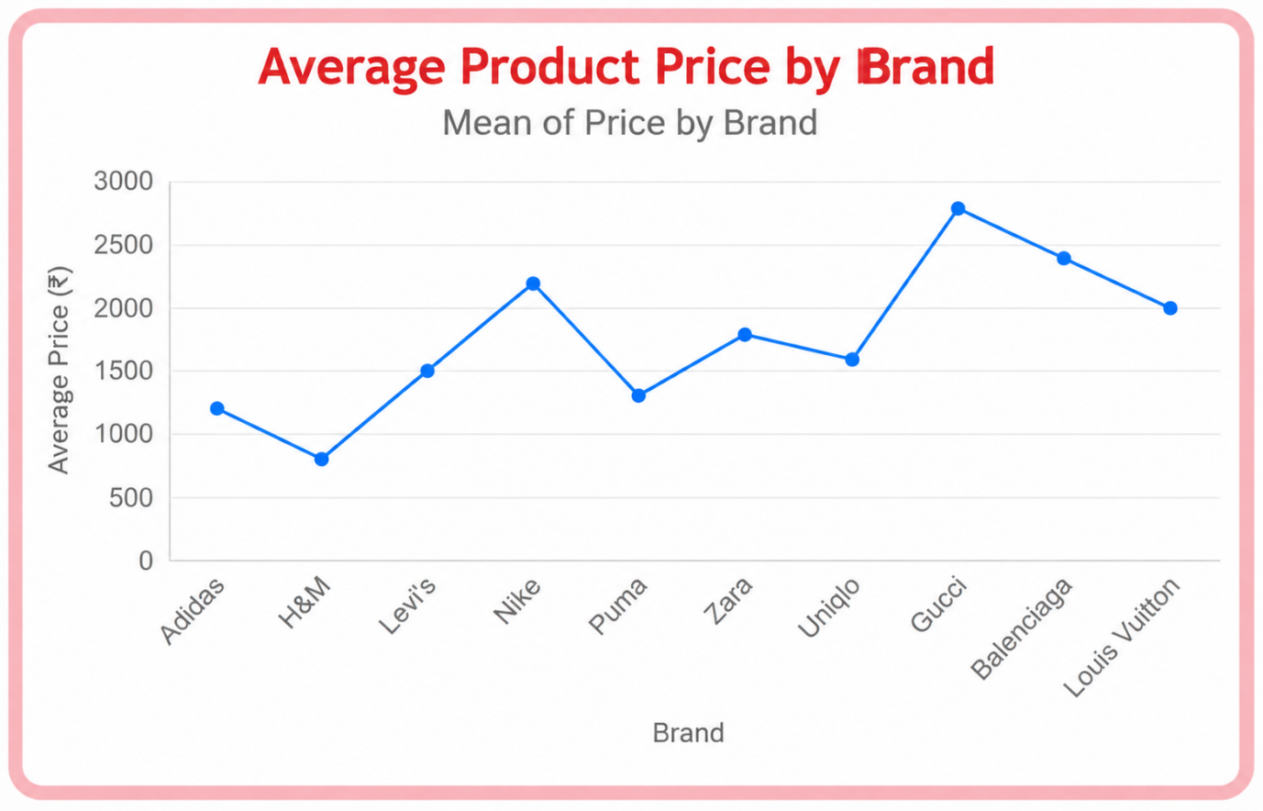

BAR CHART
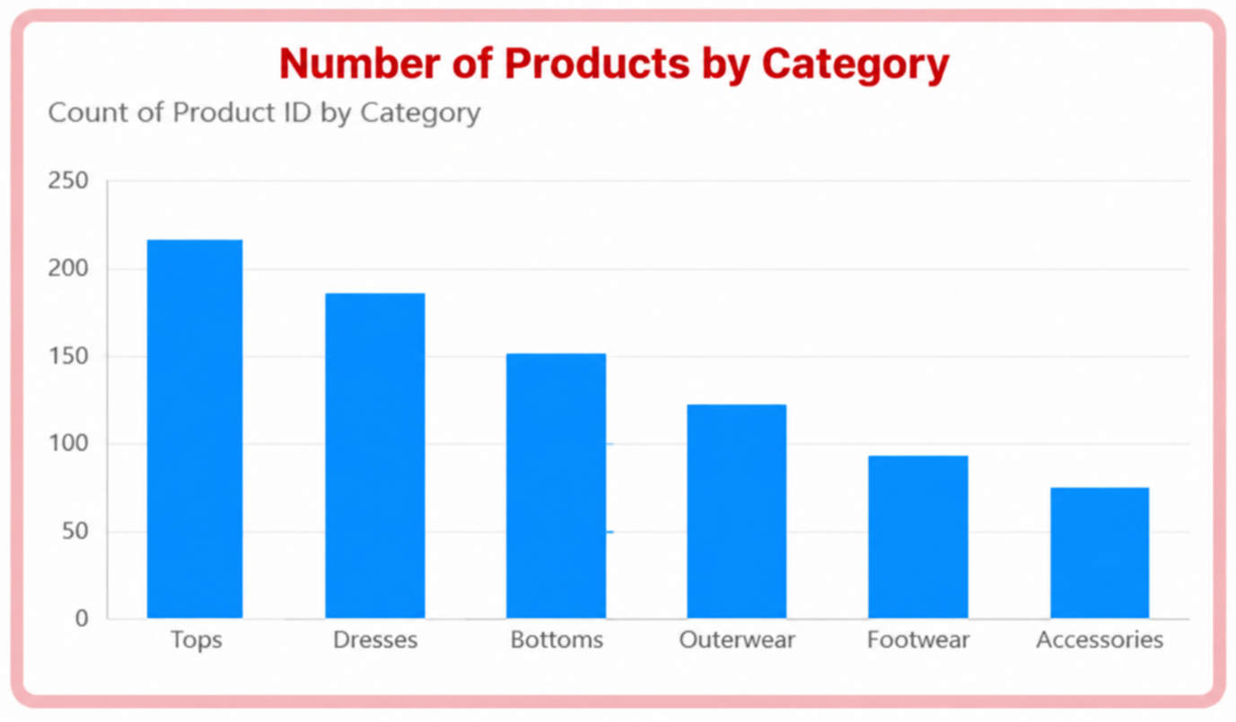

PIE CHART
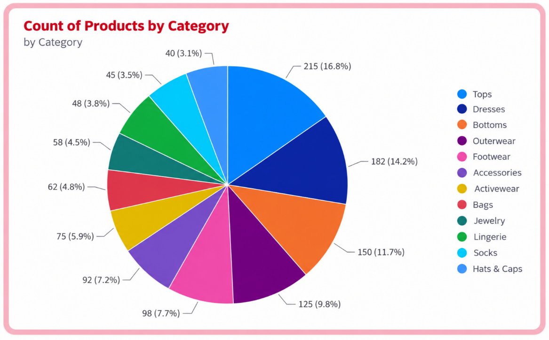

RESULT

